EXECUTION CONTEXT _ AKSHAY
Everything in JS happens inside the execution context
In Execution context, first component is the Memory Component, where all the functions and variables are stored as the {key, value} pairs
This memory component is also known as variable environment
The second component of this execution context is the code component, here code is executed one line at a time
This code component is called thread of execution
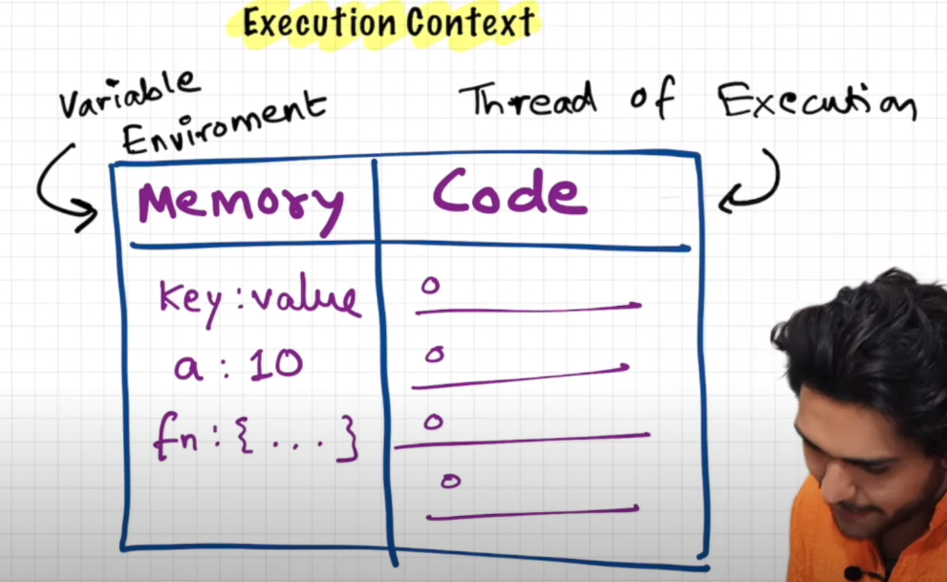
JavaScript is a synchronous single-threaded language
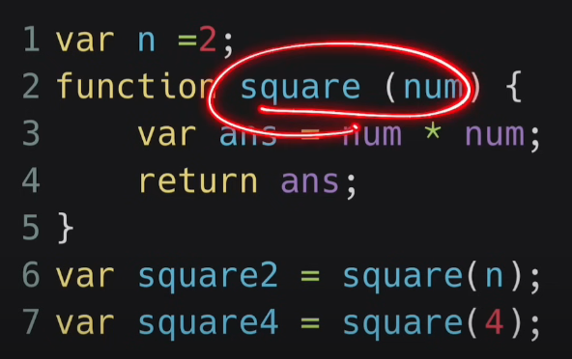
Now let us see how the whole JavaScript runs behind the scenes ->
When you first run this code, a global execution context (GEC) is created
Now again this execution context is created in two phases:
- Creation phase(Memory Creation phase)

JS will allocate memory to all the variables and functions

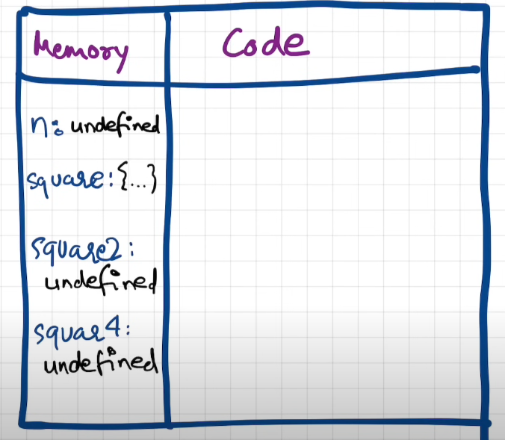

- Code Execution Phase

Runs JS code line by line
See, in the code execution phase, we first come across line var n = 2, and we replace the value undefined that we assigned to n in the Memory phase to 2
At line number 6, we invoke a function, altogether a new execution context is created
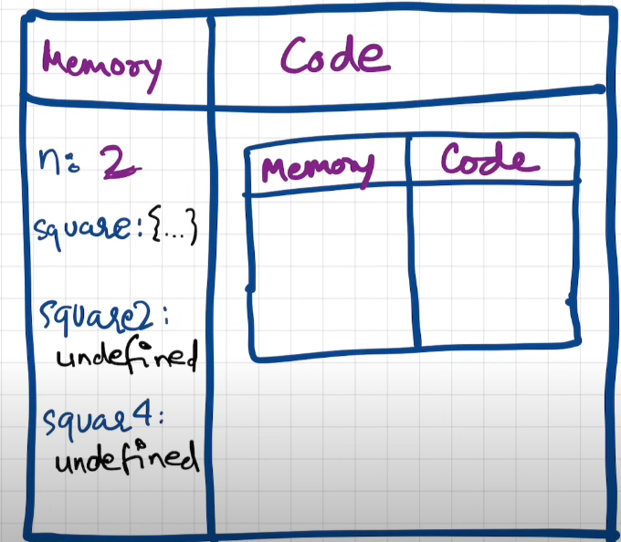
Now in this execution context, again two phases are involved, i.e. Memory Creation and Code Execution
In memory creation, num and ans will get undefined
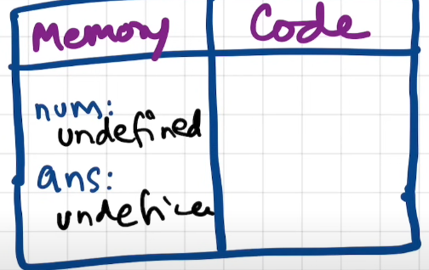
In code execution phase, value 2 is passed to num, and then coming to ans we will put num x num into ans
So its like executing the code inside the code block and assigning that value to ans
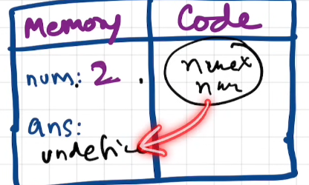
And when we come to the line return ans, it means work of this execution context is done and return the control back to the context where the function was invoked
Value of ans will be put into square2
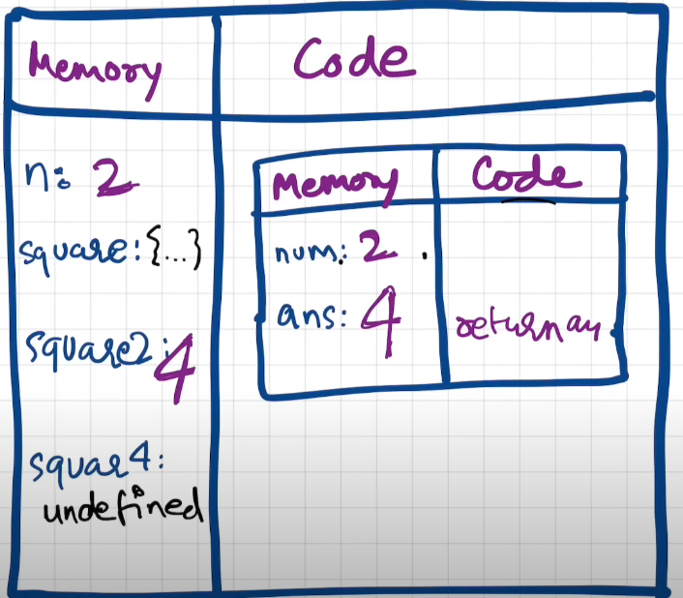
Again a new execution context is created when we hit the line square(4) and once the whole program is run, the entire global execution context is also deleted

Call Stack maintains the order of execution of these execution contexts

Additional Information ->

In JavaScript, during the variable environment phase (also called the "creation phase" or "hoisting phase"), the behavior for variables declared with let, const, and var differs:
- var:
  - Variables declared with var are hoisted and assigned an initial value of undefined.
  - This means you can access the variable before its declaration, but it will return undefined.
console.log(x); // undefined
var x = 10;
- let and const:
  - Variables declared with let and const are also hoisted, but they are placed in a "temporal dead zone" (TDZ) until their actual initialization in the code.
  - They are not assigned a value of undefined. Instead, they remain uninitialized until the code execution reaches their declaration.
  - If you try to access them before their declaration, you'll get a ReferenceError.
console.log(y); // ReferenceError: Cannot access 'y' before initialization
let y = 20;
So, during the variable environment phase, undefined is only stored for variables declared with var, not for those declared with let or const. The latter are uninitialized until their declarations are executed.

